Digital Fuel Level Indicator and Reserve Alarm

line 1: 1st Given Name Surname
line 2: dept. name of organization
(of Affiliation)
line 3: name of organization
(of Affiliation)
line 4: City, Country
line 5: email address or ORCID
line 1: 4th Given Name Surname
line 2: dept. name of organization
(of Affiliation)
line 3: name of organization
(of Affiliation)
line 4: City, Country
line 5: email address or ORCID
line 1: 2nd Given Name Surname
line 2: dept. name of organization
(of Affiliation)
line 3: name of organization
(of Affiliation)
line 4: City, Country
line 5: email address or ORCID
line 1: 5th Given Name Surname
line 2: dept. name of organization
(of Affiliation)
line 3: name of organization
(of Affiliation)
line 4: City, Country
line 5: email address or ORCID
line 1: 3rd Given Name Surname
line 2: dept. name of organization
(of Affiliation)
line 3: name of organization
(of Affiliation)
line 4: City, Country
line 5: email address or ORCID
line 1: 6th Given Name Surname
line 2: dept. name of organization
(of Affiliation)
line 3: name of organization
(of Affiliation)
line 4: City, Country
line 5: email address or ORCID

Abstract—The theft and misuse of fuel are the primary issues that concern transportation sectors, fleet owners, and people who operate machinery powered by fuel. Conventional fuel monitoring systems like manual gauges or the regular check-ups lack efficiency, are prone to errors and also they are subject to manipulations. In this paper, a Digital Fuel Level Indicator and Reserve Alarm System based on IoT technology, GSM communication, and ESP32 microcontroller will be introduced to offer real-time and automated fuel monitoring and theft detection. The ultrasonic sensor monitors the volume of fuel constantly in the tank and the ESP32 processes this information to identify sudden reduction which could be a result of theft or leakage. In case of abnormal change in fuel levels, the system will instantly alert the registered user in form of SMS using the GSM module and at the same time, update the IoT cloud dashboard, which will allow real-time visualization and analysis of historical trends. Remote monitoring, data logging and better decision making in fuel management is guaranteed by incorporation of cloud connectivity. The outcomes of the experiment prove that the system is right in identifying the fuel variability, timely warning generation, and stable data delivery to the cloud server. Its suggested solution is cheap, scalable, and applicable to other real-worlds, such as vehicles, generators, and industrial fuel tanks. This system saves a considerable amount of money, improves security, and efficient fuel management practices through automating fuel patrolling and providing advance warnings against potential losses.
Keywords—Fuel Theft Detection, Digital Fuel Indicator, ESP32, Ultrasonic Sensor, GSM Communication, IoT Monitoring, Real-Time Fuel Level, Embedded Systems, Cloud Dashboard.

Introduction
Modern society is heavily dependent on fuel as it drives transport, industrial machines, and electricity. The growing need of fuel coupled with its high prices makes fuel theft one of the burning issues to individuals, fleet operators and the industries. Conventional ways of monitoring fuel e.g. using manual gauges and regular checks are ineffective, prone to errors and subject to manipulation resulting in massive monetary losses and working interruptions [1]. To tackle such issues, current solutions combine innovative sensors, microcontrollers and communication to facilitate real-time monitoring and detection of theft.
Prabhu et al. [1] suggested an IoT-fuel monitoring system that involves ultrasonic, flow, and vibration sensors and GPS position tracking and ESP32 direct connection, which offer real-time notifications about fuel theft and leakage. In the same way, Erlina et al. [2] created an Arduino grounded prototype of BTS generator sets, demonstrating the sufficient ability to monitor the fuel volume and provide real-time reporting with the assistance of NodeMCU ESP32 and cloud connection. GSM-based notification systems have also been effective when it comes to a quick alert system as Saini and Khan [3] show in their study where SMS and buzzers are used to alert vehicle owners instantly when a fuel theft occurs.
Further recent investigations have helped improve accuracy in monitoring through the incorporation of the state-of-charge monitoring and resistance-based fuel level sensors in hybrid and electric vehicles. Mathi et al. [4] have revealed that GPS, GSM, and on board sensor combination can give the ability to detect the rapid change in fuel, abnormal battery behavior, and instant alert generation. Kurundkar et al. [5] highlighted the practicality of the GSM based car fuel theft system, which offers very good security to cars and motorcycles since it monitors fuel level and when a thief is identified, it sends an alert.
In spite of these innovations, there is still a requirement of cost effective, scalable, easily deployable solutions that can be used to offer continuous, automated fuel monitoring to a large variety of applications such as vehicles, industrial tanks and generators. The given paper suggests a Digital Fuel Level Indicator and Reserve Alarm System based on the use of IoT, GSM, and ultrasonic sensing technologies to fill these gaps, including real-time alerts, cloud-based monitoring, and improved operational security.

Related Works
A number of recent researches have dealt with the issues of fuel theft and ineffective fuel management based on the use of IoT, embedded systems and real-time monitoring technologies. A system proposed by Bhilegaonkar et al. [6] to prevent fuel theft in tankers using the IoT is a secure system with continuous monitoring of fuel level, two-password keypad authentication, and a built-in location tracking using GPS. Both the driver and fuel agency are alerted in the event that the fuel becomes below a set volume of limit, to avoid any unsafe dispensing and communication between the receiver and sender. The fuel monitoring system based on an Arduino and designed by Madhavan et al. [7] was focused on the affordability and ease of development and implementation in vehicles. Real-time fuel level sensing and GSM communications are employed by the system to alert vehicle owners immediately in case of theft, which is an active and friendly solution to a parking lot that does not depend on CCTV to add security. Likewise, Sharan et al. [8] surveyed systems of smart fuel monitoring systems that are integrated with mobile applications, noting that ultrasonic sensors and GSM-based notifications have been used to identify the presence of fuel leakage and fuel theft as well as supporting data management and reporting via smartphone interfaces.
Ahmed Abdalmaged et al. [9] proposed an all-inclusive IoT-based smart fuel monitoring system, which involves the use of a Raspberry Pi controller to measure the fuel level, temperature, pressure, pH, and the concentration of gasses. The system is efficient in fuel anomaly detection and prevent adulteration as well as fuel theft through remote control and monitoring using mobile and web applications. The methodology employed by Zinnah Ayon and Asaduzzaman [10] is an ultrasonic sensor-based system with clustering algorithms in order to classify fuel tank activities including regular use, theft, leakage and refill. Applying the Extended K-means and Agglomerative clustering, the system has been found very accurate in error detection and presented information based framework of intelligent fuel monitoring.
The most recent studies have also contributed to fuel monitoring systems through providing motion tracking, energy-saving measures, and improved sensor devices. Farzana et al. [11] suggested a motion-based fuel monitoring method that is real-time and takes into account the vehicle motion parameters (orientation, acceleration, and vibration) to enhance the precision of the fuel level measurement. It can identify suspicious activity like fuel theft or leakages and determine refills by means of temporal analysis of the fuel data with an 80 percent success rate in determining the correct refills level and 100 percent in determining refills and abnormal consumption.
Hou et al. [12] introduced a real-time energy management system of fuel cell electric vehicles that integrates off-line optimization and online fuzzy control in order to achieve effective distribution of power between the battery and fuel cell. Even though this is mainly aimed at the energy control, the rationale shows the need to incorporate real-time data processing to control optimum fuel consumption and monitoring in the contemporary vehicular systems.
Patil et al. [13] examined the capacitive sensors in the measurement of the fuel level in vehicles with accuracy. Their efforts emphasize on the importance of cheap and accurate sensors on a vehicle including two-wheelers and three-wheelers that enable proper fuel measurements and minimal difference between bought and real amounts of fuel.
Likewise, M. S. et al. [14] designed an ultrasonic and flow sensor-based digital fuel monitoring system to be used in automobiles connected to an Arduino board. The system is able to monitor the fuel levels in real-time with an accurate reading that is shown in an LCD and this illustrates a low-cost and realistic solution to the liquid-level monitoring in different vehicles. Akula et al. [15] presented an idea of a sensor-based monitoring system on fuel, which measures the fuel level with the help of distance sensors and informs its users about the nearest petrol station, fuel quality through density, and pollution of vehicles. Such a multi-functional solution makes the use of the vehicle more convenient and leads to its sustainable functioning.
Taken together these studies highlight the necessity to incorporate sensors, microcontrollers and real-time data processing to enhance fuel security, accuracy and user friendly nature and form the basis of robust IoT-based fuel monitoring solutions compatible with a variety of automotive and industrial needs.

Proposed System
The Digital Fuel Level Indicator and Reserve Alarm System proposed is meant to offer the accurate real time fuel monitoring, identify cases of fuel theft and provide timely alerts to avoid any losses. This system incorporates an ESP32 microcontroller and an ultrasonic sensor, a GSM module, and an internet of things cloud platform to enable a smooth monitoring and automation process. The ultrasonic sensor is attached to the top of a fuel tank which measures the distance between the sensor and a fuel surface. This is translated into a precise level of fuel that is constantly transmitted into the ESP32 microcontroller. These readings are processed by the microcontroller to detect normal fuel consumption trends and detect a sudden decrease in fuel level, which may either be an indication of possible theft, leakage or unauthorized use of fuel.
Once the fuel content reaches a predetermined reserve point or an abrupt decrease is noticed the ESP32 will automatically activate the GSM module to alert the registered user via SMS. At the same time, fuel level information is sent to the IoT cloud platform where it is visualized on a dashboard to be monitored in real-time and analyzed based on historical trends. This cloud integration enables users to have an access of fuel information remotely, improving the decision-making process and also operational efficiency. The system is easy to install, maintain, and is very reliable and thus suitable to implement in vehicles, generators, and industrial fuel tanks. The experimental testing indicates that the system is capable of precise detection of any changes in fuel levels, transfer real-time information to the cloud accountant and produce prompt notifications, which will help reduce the losses of the economy to the lowest possible.
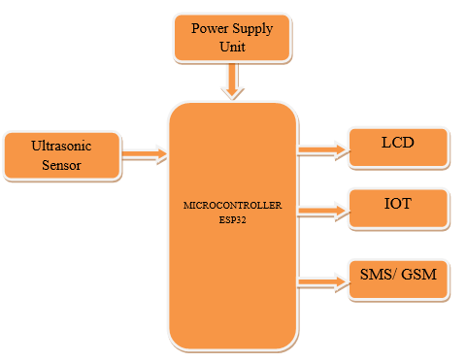
Figure.1 Proposed Block Diagram
The proposed Fuel Theft Detection and Indication System is represented in the Figure.1 block diagram that demonstrates the connection between main components that collaborate in order to monitor and alert in real time the level of fuel in the vehicle.
- Ultrasonic Sensor: The sensor is mounted on the top of the fuel tank and continuously monitors the distance between the sensor and the fuel surface giving the correct details of the level of fuel. Each case of a sudden decrease in the fuel level is considered to be a possible theft or leakage.
- ESP32 Microcontroller: The core control that is going to be used is the ESP32, which the ultrasonic sensor feeds data to, which is then processed and compared with predetermined thresholds. It displays the state of the fuel level as being normal or in reserve or abnormally dropping as a sign of theft.
- LCD Display: LCD displays local visual information about the level of fuel available, whether it is in reserve or not, and any warning information to allow the user access to the fuel conditions directly at the tank.
- GSM Module: When theft or abnormal fuel activity is detected, the ESP32 activates the GSM module to send an SMS notification to the mobile number that is registered in it. This will make sure that the user is alerted at all times even when they are not around the vehicle or fuel tank.
- IoT Module / Cloud Dashboard: At the same time, the data about the fuel level are sent to a cloud-based IoT system which allows to monitor the state remotely in real-time, record the data, and analyze the trends. This information is available to the users through smartphones or computers, enhancing transparency and fuel management.
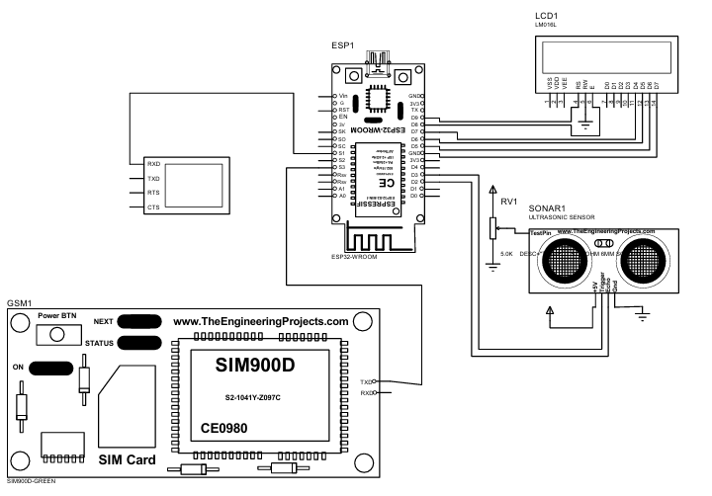
Figure.2 Circuit Diagram
The Figure.2 circuit of the Digital Fuel Level Indicator and Reserve Alarm System integrates the ESP32 microcontroller, ultrasonic sensor, GSM module, LCD display, and power supply. The ultrasonic sensor is connected to the ESP32’s digital I/O pins to provide continuous fuel level readings. The LCD display is interfaced via I²C or parallel connections to show fuel level and status locally. The GSM module is linked to the ESP32 through UART communication for sending SMS alerts in case of theft or abnormal fuel drops. A regulated 5V/3.3V power supply ensures stable operation of all components. The ESP32 also communicates with the IoT cloud for real-time monitoring.

Methodology
The proposed Digital Fuel Level Indicator and Reserve Alarm System is designed to provide real-time monitoring, theft detection, and automatic alerting for fuel-powered motors or machinery. The method integrates sensor-based measurement, microcontroller processing, Wi-Fi conversation, and cloud-based monitoring to reap a strong gas control gadget.

Fuel Level Measurement
The ultrasonic sensor is mounted at the top of the fuel tank. It continuously measures the distance (d) from the sensor to the surface of the fuel. The fuel level (L) is calculated using:
$$L=H-d$$
Where:
- H = Maximum height of the fuel tank
- d = Measured distance from the sensor to fuel
- L = Computed fuel level
This will enable the non-contact, precise measurement of the fuel volume plus, remove mechanical errors of the traditional gauges.

Data Processing and Evaluation of Thresholds.
The ultrasonic sensor gives data to the ESP32 microcontroller. It constantly makes a comparison of the level of fuel measured and predetermined limits:

- Normal range- the fuel level has been reported within the limits of consumption.
- Reserve level - means that there is a low fuel level and thus early refueling is done.
- Sudden drop detection – a rapid decrease in fuel level $\left(∆L>∆L_{Threshold}\right)$ indicates possible theft or leakage.

The ESP32 uses an internal algorithm to filter out noise or false readings, ensuring accurate detection and reducing false alarms.

Notification and Change of Direction.
When an abnormal amount of fuel is registered or an abrupt decrease is experienced, the ESP32 activates the GSM module to send an SMS notification to the registered user to act as a direct alert that there is a possibility of theft. At the same time, the information is posted on an IoT cloud.

Local Monitoring
A LCD screen attached to the ESP32 displays the real-time fuel level and reserve warnings so that on-site monitoring is possible without having to access the cloud.

Monitoring and Historical Analysis in the cloud.
The data on the fuel level is stored on the cloud platform enabling the users to:

- Check the levels of fuel remotely over-the-air.
- The past consumption can be seen to plan better.
- Get notifications and alerts even when not at the tank or the vehicle.

Workflow Summary
The system follows a continuous monitoring loop:
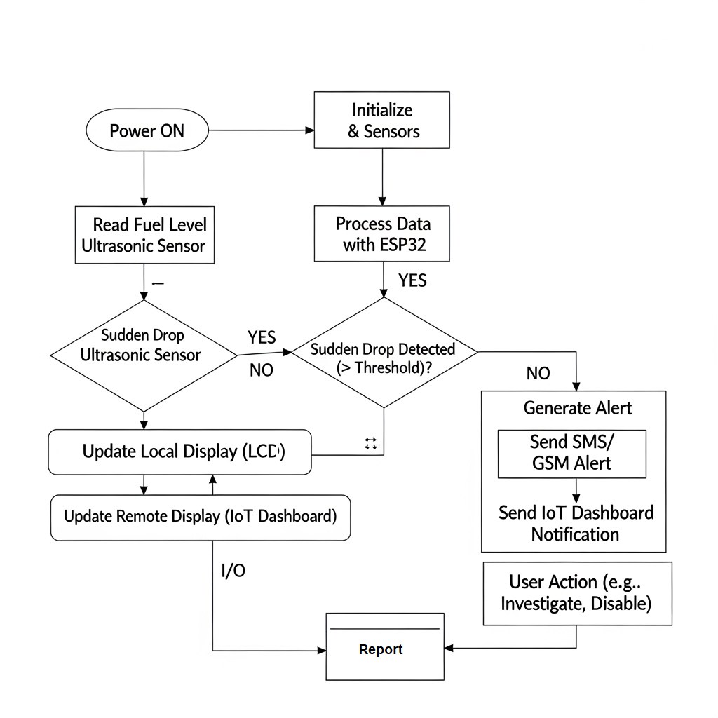
Figure.3 System Workflow

The Figure.3 workflow diagram of the Digital Fuel Level Indicator and Reserve Alarm System represents the sequential process of fuel monitoring, anomaly detection, and alert generation. The system begins with the ultrasonic sensor continuously measuring the distance to the fuel surface inside the tank. These readings are sent to the ESP32 microcontroller, which calculates the actual fuel level and evaluates it against predefined thresholds. If the level falls below the reserve threshold or a sudden drop is detected, the ESP32 identifies it as a potential theft or leakage event. At this stage, two actions are triggered: (i) the GSM module sends an SMS alert to the registered user, and (ii) the data is updated on the IoT cloud dashboard for real-time monitoring and historical analysis. Simultaneously, the LCD display provides local visualization of the current fuel status. This workflow ensures continuous monitoring, immediate notification, and secure data management for effective fuel theft prevention.

Result & Discussion
The proposed Digital Fuel Level Indicator and Reserve Alarm System was tested under real-time conditions to validate its performance in detecting fuel theft, monitoring reserve levels, and providing timely alerts. The evaluation focused on parameters such as fuel level accuracy, theft detection efficiency, alert response time, and IoT data stability.

Fuel Level Measurement Accuracy
The system was tested with different fuel levels in a 40 cm deep tank. The ultrasonic sensor readings were compared with actual measured values. Results show that the system consistently maintained high accuracy, with an error margin of less than 2.5%.
- Fuel Level Measurement Accuracy
Actual Fuel Level (cm) | Sensor Reading (cm) | Error (%)
10 | 9.8 | 2.0
20 | 19.6 | 2.0
30 | 29.3 | 2.3
40 | 39.2 | 2.0

Theft Detection Performance
To test theft detection, fuel was suddenly withdrawn from the tank. The system detected every instance of sudden drop greater than 3 cm and generated alerts within 4–6 seconds.
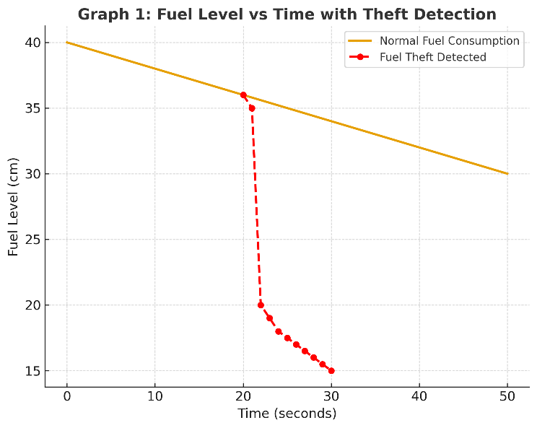
Figure.4 Fuel Level vs Time with Theft Detection

- Y-axis: Fuel Level (cm)
- X-axis: Time (seconds)
The Figure.4 graph shows normal gradual fuel consumption compared to sudden sharp drops, where alerts were generated instantly.

Alert and Communication Efficiency
The GSM module successfully sent SMS alerts to the registered user with an average delay of 4.8 seconds. Simultaneously, the IoT dashboard updated in real-time, ensuring remote monitoring without delay.
- Alert Response Time
Event Type | Detection Time (s) | SMS Alert Time (s) | IoT Update (s)
Reserve Level | 3.2 | 4.5 | 3.5
Sudden Drop | 3.8 | 4.8 | 3.6

Discussion
The results demonstrate that the system is highly reliable in monitoring fuel levels, with minimal error and robust theft detection capabilities. The integration of IoT and GSM ensures real-time monitoring both locally and remotely, making the system practical for fleet operators, industries, and individual users. The low error margin, quick alert response, and stable IoT data flow prove that the proposed solution is cost-effective, scalable, and efficient for real-world fuel management applications.

Conclusion
The proposed Digital Fuel Level Indicator and Reserve Alarm System successfully addresses the growing problem of fuel theft and inefficient monitoring in vehicles, generators, and industrial fuel tanks. By integrating an ultrasonic sensor, ESP32 microcontroller, GSM communication, and an IoT cloud dashboard, the system provides a reliable, automated, and real-time solution for fuel management. Experimental results demonstrate that the system achieves high accuracy in fuel level measurement, with a minimal error margin of less than 2.5%. It effectively detects sudden drops in fuel level, ensuring timely theft detection and rapid alert generation within seconds. The use of GSM technology ensures that users are instantly informed via SMS, while the IoT platform allows remote access to live data and historical trends, enhancing operational efficiency and decision-making.
The solution is designed to be cost-effective, scalable, and user-friendly, making it adaptable for a wide range of applications. By minimizing dependency on manual monitoring, reducing human error, and providing proactive theft prevention, the system enhances both security and economic savings. Overall, the proposed work demonstrates a practical and innovative approach to fuel management, contributing toward smarter, safer, and more efficient energy utilization in real-world applications.

References
- S. B. Prabhu, K. Deepa and M. Nithya, "IoT Enabled Fuel Level Monitoring and Automatic Fuel Theft Detection System," 2022 13th Int. Conf. on Computing Communication and Networking Technologies (ICCCNT), Kharagpur, India, 2022, pp. 1-7, doi: 10.1109/ICCCNT54827.2022.9984515.
- T. Erlina, R. Aisuwarya and Alwizar, "Safeguarding Fuel Resources for BTS Generator Sets: An Arduino-Based Monitoring System with Fuel Theft Detection Prototype," 2023 Int. Conf. on Information Technology Research and Innovation (ICITRI), Jakarta, Indonesia, 2023, pp. 1-6, doi: 10.1109/ICITRI59340.2023.10249772.
- M. Saini and S. Khan, "GSM Based Fuel Theft Detection," 2021 1st Int. Conf. on Power Electronics and Energy (ICPEE), Bhubaneswar, India, 2021, pp. 1-6, doi: 10.1109/ICPEE50452.2021.9358644.
- S. C. Mathi, S. Reddy Jambula, D. A. Surat, M. C. Maridinapalli, M. P V and V. Sailaja, "Development of an Intelligent Fuel Monitoring and Theft Detection System Equipped with GPS & GSM Integration, State of Charge Monitoring and Realtime Alarm Generation," 2024 Int. Conf. on Inventive Computation Technologies (ICICT), Lalitpur, Nepal, 2024, pp. 2095-2102, doi: 10.1109/ICICT60155.2024.10544646.
- S. Kurundkar, R. Sapate, S. Raut, S. Rathod and S. Khopade, "Vehicle Fuel Theft Detection System," 2024 Int. Conf. on Sustainable Communication Networks and Application (ICSCNA), Theni, India, 2024, pp. 1570-1577, doi: 10.1109/ICSCNA63714.2024.10864281.
- P. Bhilegaonkar, R. Patil, A. Belekar, M. Gujarathi and S. Sondkar, "Fuel Theft Prevention System," 2020 Int. Conf. on Industry 4.0 Technology (I4Tech), Pune, India, 2020, pp. 126-130, doi: 10.1109/I4Tech48345.2020.9102689.
- A. Madhavan, S. S. J, Ayyarraja and S. A, "Detecting Fuel Theft with Arduino," 2024 Second Int. Conf. on Emerging Trends in Information Technology and Engineering (ICETITE), Vellore, India, 2024, pp. 1-6, doi: 10.1109/ic-ETITE58242.2024.10493392.
- P. Sharan, H. A. Mir, S. Maqbool, A. Singh, P. Yadav and S. K. Chaudhary, "A Review on Smart Fuel Theft Prevention and Monitoring System Using Mobile Application," 2023 Int. Conf. on Computational Intelligence and Sustainable Engineering Solutions (CISES), Greater Noida, India, 2023, pp. 640-644, doi: 10.1109/CISES58720.2023.10183636.
- I. M. Ahmed Abdalmaged, S. N. Saud Al-Humairi, A. M. Hezam Al-Hakimi and A. Kumari, "Design and Implementation of IoT-Based Smart Fuel Monitoring System," 2025 21st IEEE Int. Colloquium on Signal Processing & Its Applications (CSPA), Pulau Pinang, Malaysia, 2025, pp. 32-37, doi: 10.1109/CSPA64953.2025.10933356.
- W. I. Zinnah Ayon and Asaduzzaman, "Ultrasonic Sensor-based Fuel Monitoring System using Clustering Technique," 2023 26th Int. Conf. on Computer and Information Technology (ICCIT), Cox's Bazar, Bangladesh, 2023, pp. 1-6, doi: 10.1109/ICCIT60459.2023.10441037.
- F. Farzana, M. M. Hossain, M. M. Imtiaze, M. T. Hossain, A. S. M. M. Jameel and S. Islam, "A Real-Time Motion Based Fuel Monitoring Technique For Vehicle Tracking Systems," 2020 Emerging Technology in Computing, Communication and Electronics (ETCCE), Bangladesh, 2020, pp. 1-6, doi: 10.1109/ETCCE51779.2020.9350860.
- S. Hou, H. Yin, B. Pla, J. Gao and H. Chen, "Real-Time Energy Management Strategy of a Fuel Cell Electric Vehicle With Global Optimal Learning," IEEE Trans. on Transportation Electrification, vol. 9, no. 4, pp. 5085-5097, Dec. 2023, doi: 10.1109/TTE.2023.3238101.
- K. Patil, C. Y. Patil and S. Barhate, "Design and development of fuel level measurement technique for automotive application," 2019 Int. Conf. on Communication and Electronics Systems (ICCES), Coimbatore, India, 2019, pp. 1-5, doi: 10.1109/ICCES45898.2019.9002542.
- S. M, E. R. G, P. Ramprasad, C. V. Reddy and B. S. Prasad, "Digital Fuel Monitoring System For Automobiles," 2021 Second Int. Conf. on Electronics and Sustainable Communication Systems (ICESC), Coimbatore, India, 2021, pp. 6-10, doi: 10.1109/ICESC51422.2021.9532604.
- R. Akula, B. R. Sai, K. Jaswitha, M. S. Kumar and V. Yamini, "Sensor Based Quality Check and Automated Fuel Level Indication System," 2019 3rd Int. Conf. on Recent Developments in Control, Automation & Power Engineering (RDCAPE), Noida, India, 2019, pp. 164-168, doi: 10.1109/RDCAPE47089.2019.8979067.

